

**Come From Away**

**Audition Pack**

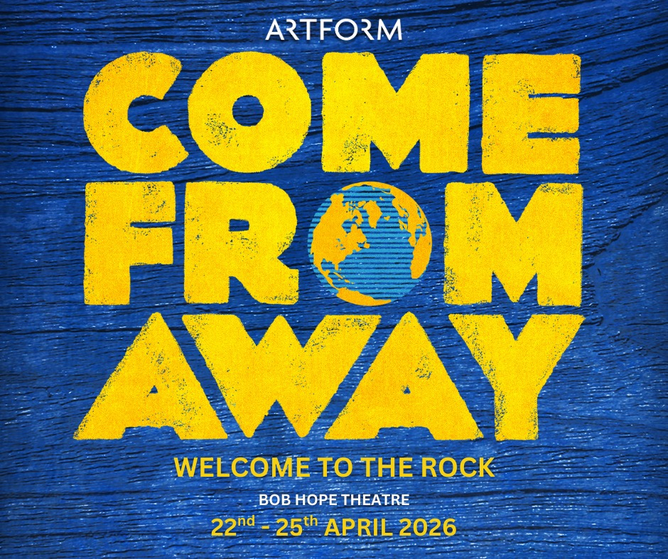

**Key dates:**

**Auditions:** Sunday2 November 2025 from 12 midday, at The Corbett Library, 103 Torridon Road, SE6 1RQ

**Call backs/additional auditions:** Thursday 6th November 2025, Hayes School,

W Common Rd, Bromley 7DB from 7pm

**Performance week:** 22-25 April 2026

**Performance Venue:** Bob Hope Theatre, Wythfield Rd, Eltham, SE9 5TG

The Bob Hope Theatre is a popular South East London venue, home to its own Actors’ Company, as well as hosting productions for a number of local societies. It seats approximately 200.

There are good transport links from London, with Eltham station a five-minute walk, and with many local buses serving the area.

**Show Synopsis:**

*Come From Away* tells the true story of 7,000 airline passengers stranded in Gander, Newfoundland, after the September 11th terrorist attacks. The show focuses on the small town's extraordinary hospitality and how they welcomed and supported the displaced travellers, showcasing the best of humanity amidst tragedy. The musical explores the interactions between the *plane people* and the *Islanders,* highlighting themes of generosity, compassion, and the forging of unexpected friendships.

**Plot:**

On the morning of September 11, 2001, the townsfolk of Gander (including Claude the mayor, Oz the police constable, Beulah the teacher, Bonnie the SPCA worker, and others) describe life in Newfoundland and how they learn of the terrorist attacks taking place in New York City, Washington DC, and Shanksville, Pennsylvania ("Welcome to the Rock").

The attacks result in the closure of US airspace, diverting 38 international aircraft to Gander International Airport. The passengers on these aircraft doubled the population of the small Newfoundland town, which is unequipped for the influx of stranded travellers ("38 Planes").

The Gander townspeople spring to action and prepare to house, feed, clothe, and comfort the nearly 7,000 passengers, along with 19 animals in cargo ("Blankets and Bedding"). Meanwhile, the pilots, flight attendants, and passengers are initially forbidden from leaving the planes, forcing them to contend with confusing and conflicting information about what has happened and why they were suddenly grounded ("28 Hours / Wherever We Are").

Once allowed off the planes and transferred to nearby emergency shelters ("Darkness and Trees"), the passengers and crew watch replays of the attacks on the news and learn the true reason why they were grounded ("Lead Us Out of the Night").

The frightened and lonely passengers desperately try to contact their families and pray for their loved ones while the townsfolk work through the night to help them in any and every way they can ("Phoning Home / Costume Party"). The travellers are initially taken aback by their hosts' uncommon hospitality, but they slowly let their guards down and begin to bond with the quirky townsfolk and each other.

The "islanders" in Gander and the surrounding towns open up their homes to the "plane people", regardless of their guests' race, nationality, or sexual orientation. Two women, Beulah (from Gander) and Hannah (from New York), bond over the fact that both of their sons are firefighters, but Hannah's son remains missing after the attacks ("I Am Here"). Hannah asks Beulah to take her to a Catholic church, and a number of characters make their way to other houses of worship around town ("Prayer").

To alleviate rising fear and mounting tensions ("On the Edge"), the townspeople invite the passengers to be initiated as honorary Newfoundlanders at the local bar ("Heave Away / Screech In").

The gravity of the attacks nevertheless continues to set in as US airspace is eventually reopened. One trailblazing pilot, Beverley Bass, comments on how her once optimistic view of the world has suddenly changed ("Me and the Sky”).

While one pair of passengers develops a romance despite the terrible circumstances ("The Dover Fault/Stop the World"), another couple's long-term relationship falls apart under the stress of the event.

As the passengers and crew fly away to their homes, they joyously exchange stories of the immense kindness and generosity that the Newfoundlanders showed the strangers in their time of need ("Somewhere in the Middle of Nowhere"), but not before a Muslim traveller, faced with increasing prejudice from his fellow passengers, undergoes a humiliating strip search prior to boarding.

The townsfolk in Gander return to normalcy but comment on how empty their town now seems and how different the world now feels. The passengers and airline staff who return to the United States are faced with the horror of the attacks' aftermath — including Hannah, who learns that her firefighter son died during the rescue efforts ("Something's Missing").

Ten years later, the crew and passengers of the once stranded planes — the "come from aways" — reunite in Gander, this time by choice, to celebrate the lifelong friendships and strong connections they formed in spite of the terrorist attacks ("Finale"), as Claude the mayor professes, "Tonight we honour what was lost, but we also commemorate what we found."

**Cast Requirements**

The cast requires twelve versatile actor/singer/movers, who will be required to portray both Newfoundland residents and different global plane passengers, all requiring specific accents.

Based on real people, we will be looking to cast the genders and certain global passengers as specified. However, we welcome and encourage auditions from all global majorities to audition for roles where the ethnicity is not specified.

**Come From Away – Character Breakdown and Vocal Ranges**

**(NB Come From Away-ers in Bold,** Newfoundlanders in regular type)

|  |  |  |  |  |
| --- | --- | --- | --- | --- |
| **Primary Character** | **Description** | **Secondary Characters** | **Age Range** | **Vocal Type** |
| **Diane** | Traditional divorcee from Texas, eventually finds a new lease of life. | Crystal,  Brenda | 50s-60s | Warm soprano up to D’ |
| **Hannah** | Mother of a firefighter in Manhattan, anxiously awaiting news. | Margie  Mickey  African passenger  (black actor) required) | 40s-60s | Contemporary soprano with strong belt up to E’ |
| Janice | An eager new local TV reporter | **Britney**  **Flight -attendant** | 20s | Contemporary soprano with strong belt up to E’ |
| Beulah | The head of the Gander Legion with a firefighter son | **Delores** | 40s-60s | Mezzo with belt up to B |
| Bonnie | A no-nonsense mother of 3 and animal-lover, Head of the Gander SPCA | **Martha** | 30s-40s | Mezzo with belt up to B |
| **Beverley** | The first female captain for American airlines pilot. Married with family. | **Annette**  Local teacher at the Gander Academy  **Reporter** | 40s-50s | Strong mezzo to a belted C# |
| Oz | Quirky constable of the Gander two-person police force. | Joey, Customs Officer, Mr Michaels, Terry, Matty, **Rabbi, Head cardiologist** | 30s-50s | Strong contemporary tenor up to G |
| **Kevin T** | Head of an environmental energy company in LA | Garth: union rep of bus company  **President Bush** | 30s-40s | Strong contemporary tenor up to G |
| **Kevin J** | Kevin’s boyfriend and secretary. Sarcastic, unhappy | Dwight: airport employee  **Ali:**  middle-eastern passenger  (actor to represent cultural background) | 30s-40s | Tenor or baritone |
| **Bob** | Hardened New Yorker, suspicious | **Muhumuza:** African passenger  (black actor required)  **Captain Bristol** | 20s-40s | Baritone |
| Claude | Gregarious and well-liked Mayor of Gander | Derm (Mayor of Appleton), Brenda’s brother, Eddie | 40s-60s | Rough edge to voice – baritone. High G |
| **Nick** | A single Englishman – oil engineer. He falls for Diane. | Doug: traffic Controller  Officer Stephenson | 50s-60s | Tenor/baritone to E |

**Casting**

Artform is committed to an open, fair and inclusive casting policy.

We have no preconceived ideas as to the ethnicity of any role and someone’s ethnicity will not be a factor in any casting decision, unless specified in the script.

Actors of all gender identities are very welcome to audition for any role but please note that we are not able to transpose any vocal lines, and require performers to sing in the original keys in the score. We are also not able to alter any of the libretto text, including any changes to genders.

We encourage performers with a disability to audition, but please state your access requirements on the audition form*.* Unfortunately, the stage at the Bob Hope theatre is not wheelchair accessible.

As with every show, the casting process is a jigsaw, so whilst casting of roles may need to be relative age-wise, we encourage people of all ages to audition for any role for which they feel they would be best suited. We are unable to cast anyone under the age of 16.

**Audition Pieces**

**Everything that you need for the audition can be found at this link:**

[**https://www.artform.org.uk/tickets/future-productions/forms/**](https://www.artform.org.uk/tickets/future-productions/forms/)

You will be given a time slot for your audition.

**Movement and dance:** There will be no formal movement or dance audition, although you may be asked to do some movement during your audition.

**Creatives**

**Direction:** Sheila Arden

**Musical Direction:** Jeorgie Brett

**Choreography** : Caroline Essenhigh

**Key information**

**Performance Week**

Five performances from Wednesday 22nd April – Saturday 25th April 2026

Evenings Wed, Thurs, Fri and Sat at 7.45pm. plus Sat matinee at 2.30pm

You will need to be available all day on Saturday 18th and Sunday 19th April and the evenings of Monday 20th and Tuesday 21st April for rehearsals, band call, technical rehearsal and dress rehearsal.

**Rehearsals**

**Rehearsal venues will be:**

**Corbett Library,** 103 Torridon Road, SE6 1RQ

**Hayes School,** W Common Rd, Bromley 7DB

Rehearsals will be mostly on Sundays, and Thursday evenings.

1 to 1 and small group rehearsals on other days may be negotiated with individual cast members.

Rehearsal material will be provided as soon as possible after the material loan begins, to allow you to learn lines and lyrics. It would be extremely beneficial to you, your fellow cast members and the production team if all cast members could be off-book as soon as possible.

**Publicity and ticket sales**

If you are successful and join the cast, your support with sharing of publicity material on email and social media will be encouraged as we want to make sure as many of your friends, families and colleagues see you perform. We will offer reminders at each stage of our publicity plans.

Tickets are available from :

[**https://www.ticketsource.co.uk/whats-on/london/bob-hope-theatre/come-from-away/e-rymgye**](https://www.ticketsource.co.uk/whats-on/london/bob-hope-theatre/come-from-away/e-rymgye)

**Finances**

Artform is a production company and as such does not have a membership.

A show fee of £85 will be payable; the show fee covers a variety of aspects of the production including lighting, theatre hire, rehearsal space hire, costumes, props, set, professional musicians.

Show fees can be paid in instalments if required and this can be arranged with the Artform treasurer.

***Artform Policies:***

*All auditionees are required to read our policies and indicate on the audition form that they have read and agree to these policies.*

***(Link Needed)***

**Please do contact us if you have any further queries, at:**

[**comefromaway@artform.org.uk**](mailto:comefromaway@artform.org.uk)